REGISTRATION FORM AND PARENT CONTRACT
Please return to:

Westwood Farm Community Preschool, Downs Way, Tilehurst, Reading, RG31 6SL
ADMIN@WESTWOODFARMPRESCHOOL.COM
CHILDS DETAILS Boy □ Girl □ Gender Unknown □
Child’s full name: ____________________________________________________________________________________
Known as: ______________________________________ Date of Birth: _______________________________
Birth Certificate Number: __________________________________ (We need to see the original birth certificate)
Ethnic origin: _____________________________________________ (Broad ethnic group not place of birth)
First Language: _________________________________ Other languages:_________________________________

Please indicate your child’s attendance pattern required and transfer the administration fee to our account

Days | Morning  09.00-11.45 | Lunch  11.45-12.45 | Afternoon  12.45-15.30 | Full Day  9.00-15.30
Monday
Tuesday
Wednesday
Thursday
Friday

Start date: .

MEDICAL DETAILS Any Special Medical Needs (Please Detail):
Doctor’s Name:__________________________ ____________________________________________
Address:_________________________________ ____________________________________________
_________________________________________ Any Special Dietary Requirement (Please Detail):
Telephone Number:_______________________ ___________________________________________
Are all Immunisations up to date: Yes □ No □ Any Allergies (Please Detail):
If no: State exceptions:___________________ ___________________________________________
_________________________________________ ___________________________________________
Any Special Needs or other information we _____________________________________________
may need to know to care effectively for Please detail alternative food (if appropriate)
your child (please detail):___________________ and any medication control (if appropriate)
___________________________________________ _____________________________________________

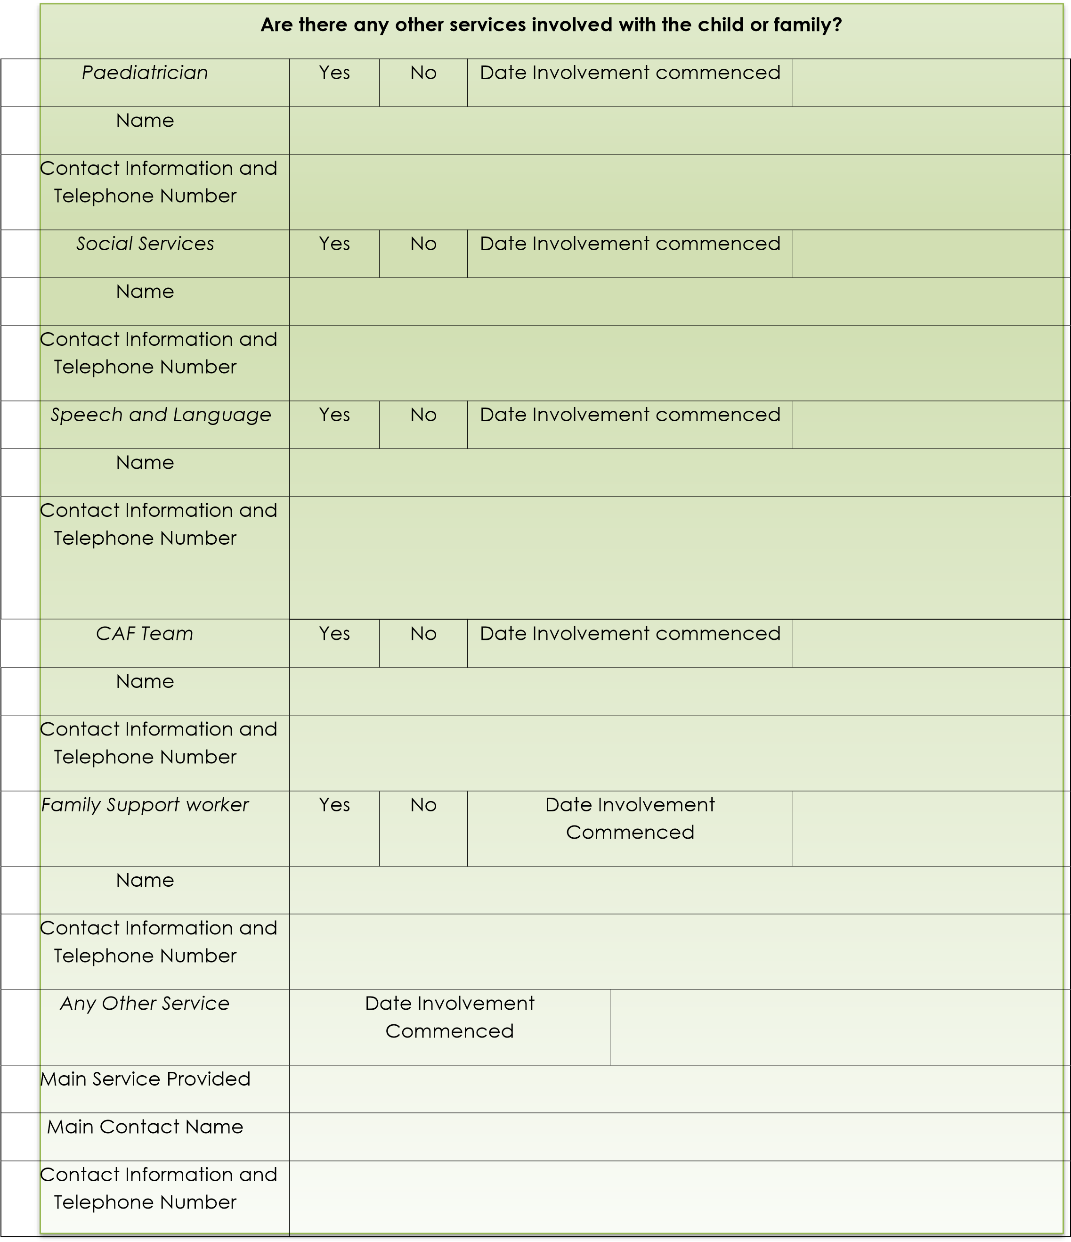

PARENT / GUARDIAN DETAILS
We need to have the details of all persons who have Parental Responsibility & Legal Contact along with those who have permission to collect the child and those who may be contacted in an emergency.
PARENT / GUARDIAN PARENT / GUARDIAN
Full name: ____________________________________ Full name: ____________________________________
Salutation: Mr Mrs Ms Dr Other _________________ Salutation: Mr Mrs Ms Dr Other _________________

Address: _____________________________________ Address: _____________________________________

_______________________________________________ _______________________________________________

_______________________________________________ _______________________________________________
Parental Responsibility: Yes □ No □ Parental Responsibility: Yes □ No □
Who does the child live with: _____________________________________________________________________
Telephone Numbers

Home: _______________________________________ Home: _______________________________________
Work: ________________________________________ Work: _______________________________________
Mobile: _______________________________________ Mobile: _______________________________________

Email Address: ________________________________ Email Address: ________________________________ If working please give details below:
Employers Name & Address: Employers Name & Address:
_______________________________________________ _______________________________________________
_______________________________________________ _______________________________________________
_______________________________________________ _______________________________________________
_______________________________________________ _______________________________________________ Please provide details of any other person with Parental Responsibility:
____________________________________________________________________________________________________

AUTHORISED TO COLLECT Names and telephone numbers of any other persons who have permission to collect your child regularly.

Full Name & Relationship:____________________________________ Full Name & Relationship:____________________________________

Home:______________________________________________________ Home:______________________________________________________

Work:_______________________________________________________ Work:______________________________________________________

Mobile:_____________________________________________________ Mobile:____________________________________________________

Childminder Name:________________________________________________________________________________________________________

Email and Contact Number:________________________________________________________________________________________________

EMERGENCY CONTACT
Names and telephone numbers of appropriate adults who may be contacted in time of emergency if you are not available.

Full Name:___________________________________________ Full Name:_______________________________________________

Home:_______________________________________________ Home:___________________________________________________

Work:________________________________________________ Work:____________________________________________________

Mobile:______________________________________________ Mobile:__________________________________________________

PASSWORD- Please provide a password that may be used for anyone who may collect your child._________________________________

PARENT CONTRACT
We believe that there needs to be a formal agreement between the Preschool and Parents. The contract will outline the obligations and commitment, of both the Preschool and the Parent(s).

This is a contract between Westwood Farm Community Preschool and the Parent(s) or legal Guardian (referred to as ‘the Parent’)
of a child (or children) that is enrolled at the Preschool.

The Preschool: -
- Will be known as ‘Westwood Farm Community Preschool’ and will operate from Westwood Farm Community Centre, Downs Way, Tilehurst, Reading, Berkshire, RG31 6SL.
- Is registered with Ofsted and operates within their regulations, guidelines and rules. Their Inspectors regularly visit the Preschool to ensure the appropriate standards of care & education are being provided.

The Contract: -
- Notice Period: Due to the long- term commitment we make when reserving a child’s place, we must ask you to make a similar commitment to us. We therefore, require a minimum of 1 calendar months written notice, commencing from the first day of the month, to reduce or cancel your child’s normal sessions.
- Any changes to sessions after the confirmation letter has been issued will incur a £10.00 administration charge.
- Increasing your sessions is subject to availability.

HOURS OF OPERATION
Monday to Friday 09:00 to 15:30. We will be closed on school holidays and all Statutory Holidays.

TERMLY FEES
The setting reserves the right to increase said fees at any time giving a terms notice of the proposed increase to parents / guardians. Termly fees include all sick days and holidays taken as these are paid days. Any statutory holidays will be deducted from your termly bill. Fees are based on booked days not attendance. Refunds and credits will not be given for days where your child does not attend due to sickness or holiday. We do not allow swapping of days unless it is permanent and there is availability, we will try to accommodate swapping of days in cases of emergency or under special circumstances. Fees will not be refunded in unusual circumstances i.e. pandemic, unless instructed by the local council or government guidelines.

GOVERNMENT FUNDING
Parents who qualify for funding will have this amount deducted from the invoice. Any fees not covered by a subsidy are the parents' responsibility and are payable by the due date on your invoice. All subsidised payments must also be paid by the date on your invoice.

PAYMENT POLICY
Parents agree that all termly fees (full time and part time attendance) will be paid by the due date on your invoice.
Additional sessions will be invoiced at the end of each month and will be due for payment immediately. Unpaid fees are subject to a £50 late payment fee. Unpaid fees may result in immediate suspension or termination of care unless reasonable arrangements are made and accepted by both parties. Extra hours are billed at the session rate.
Full time and part time fees are based on booked days, not attendance, therefore parents are responsible for fees whether their child attends or not. (This includes sick days and holidays booked.)
All payment of fees are by bank transfer only. No cheques.
Bank details are as follows:-
Trading name: Westwood Farm Community Preschool Account number: 02522230 Sort Code: 30-96-96
Please use your child’s name as a reference.

ILLNESS POLICY
Please advise the Preschool prior to 9:00 am if a child will not be attending due to illness. Parents agree that a child who is ill (e.g. fever, infection, diarrhoea, communicable disease, or any other type of illness that may be passed on to others, with the exception of the common cold) will be kept at home to protect the well-being of the staff and other children in our care. The parents further agree should a child become ill while in our care that immediate arrangement will be made to collect the child as soon as possible from the Preschool. Children will not be allowed to return to Preschool until they have been symptom free for at least 24 hours for a fever and 48 hours for sickness or diarrhoea. In some cases, a note from a doctor may be necessary. By signing this contract you are agreeing to staff seeking any necessary emergency medical advice or treatment during their time at Westwood Farm Community Preschool. Please refer to our sickness policy for more information about this topic.

MEDICINES
We will only administer prescription medicines, we will not give Calpol unless it has been prescribed. If your child has been prescribed medicine, they cannot attend preschool for a full 24 hours after the first prescribed dose has been given.
If your child has been given Calpol they will be unable to attend preschool as the use of Calpol can mask other illnesses. If your child becomes worse while in our care, we will require them to be collected as soon as possible.

LATE ARRIVAL/PICKUP POLICY
Please advise the Preschool immediately if you will be arriving later than the pre-arranged time to pick up your child. It is the
parents responsibility to ensure that children are picked up no later than 15:30. If you are not able to pick up your child by 15:30 alternate arrangements must be made.
Please notify the Preschool if an unauthorised person will be picking up your child. Verbal or written permission must be received before we will release a child to anyone who is not authorised on the registration form. Please ensure they have a password.

TERMINATION
The Preschool reserves the right to suspend or terminate care of any child without notice, should it be deemed necessary for the overall safety and well-being of staff and/or other children in our care.

PARENT CONTRACT continued

WITHDRAWAL
Notice Period: Due to the long-term commitment we make when reserving a child’s place, we must ask you to make a similar
commitment to us. We therefore, require a minimum of 1 Calendar months written notice, commencing from the first day of the
month, to reduce or cancel your child’s normal booking.

HEALTH & SAFETY
The name of the designated Health & Safety Officer is on the main notice board. Any health & safety queries please arrange to meet with the Preschool Manager. If the Preschool has to close due to any health & safety and illness reasons including bad weather, fees will still be due to be paid during the period closed.

REGISTRATION
A non-refundable administration fee of £25.00 (per child) is required upon completion of registration. The administration fee is non-refundable. Spaces will not be held unless the administration fee is paid in full.

POTTY TRAINING
We will work in conjunction with parents during potty training. If you have a method that has been working for you, please let us know and we will adopt it for your child. Should you discontinue potty training at home, please let us know. If a child shows no interest in potty training, we will discuss this with you and probably choose to discontinue and try again at a later date.

BEHAVIOUR MANAGEMENT
If a child’s behaviour is seen to endanger others and all routes according to our Behaviour policy have been adhered to Preschool
will take advice from the local authority and arrange a meeting with the parents to discuss the options available.
If a parent does not support the Preschool in gaining help and advice from outside agencies the Preschool reserves the right to terminate the parents contract and will no longer provide care for that child.

WHAT TO WEAR
In order to feel free to explore and experiment with all kinds of materials, including messy ones, it is advisable to send children dressed in clothes that are easily washable and preferably not new. It is good for children to practice the skills, which will make them independent. Simple clothing which they can handle themselves will enable them to go to the toilet unaided and to put on and take off their outdoor clothes without being too dependent on other people for help. The Preschool also requests that each child is provided with a pair of Wellington boots and a sun hat which are clearly labelled, to be kept at the Nursery.

DATA PROTECTION
I understand that my child’s records will be stored within the framework of the General Data Protection Regulations (GDPR) (2018)
and the Human Rights Act (1998). If my child attends another setting, I understand that the Preschool will establish a regular two-way
flow of appropriate information with parents and other providers. Where appropriate, the Preschool will incorporate comments from
other providers, as well as parents and/or carers into the child’s records.

SAFEGUARDING
I understand that the Safeguarding Vulnerable Groups Act 2006 places a duty on the staff to follow specific child protection procedures should any concerns be made and that there is a Safeguarding Children Policy available for me to view at any time.

NON -SOLICITATION OF STAFF
- The parent/guardian of the child who is subject to this Registration Form, hereby agrees that during the term of this agreement and for the period of six months after its termination (howsoever terminated) that (s)he will not seek to employ, entice away or attempt to entice away from the employment of Westwood Farm Community Preschool ('the Company') any person or persons employed by the Company at the date of termination of this agreement or any person or persons who were employed by the Company in the six months preceding the date of termination of the agreement.
- If the parent/guardian shall breach clause 10(a) then (s)he shall indemnify the Company fully in respect of all and any costs, claims, damages and expenses incurred by the Company as a result of the aforementioned breach to include the cost of replacing the relevant member of staff to include, but not limited to agency fees, advertising costs, management time in interviewing and all such other costs reasonably and necessarily incurred by the Company in replacing the member of staff together with all legal fees and disbursements.

EXCLUSION
If in the reasonable opinion of the settings manager or person of similar standing or authority it is considered that the continued presence of the child referred to herein is detrimental to the health, safety or wellbeing of the child or other children in the setting or the setting practitioners or other staff so employed then the setting may serve notice to the parent/guardians or a request for the child to be immediately removed from the setting and the provision of one month's notice shall not apply.

ACCEPTANCES
- All of these terms and conditions are considered to be fair and reasonable. In the event of any term found by a Court of Law
to be unreasonable then the clause shall be removed but the agreement shall remain in full force and effect.
- The parent/guardian has read and understands the Terms and Conditions contained and undertakes to be bound by the same.
This agreement must be signed by all persons with Parental Responsibility and/or those who are accepting responsibility
for paying fees. Your childcare may only commence once payment of the first invoice.
I have read and understand the Parental Agreement and I agree to be bound by it and any other relevant booking terms and conditions that are issued from time to time.

PARENT CONTRACT continued
CONSENTS
General first aid
I agree that first aid qualified staff may administer first aid to my child should it be required. Yes □ No □
Emergency first aid
Do you give permission for emergency First Aid and for staff to seek further medical advice or medical intervention in an
emergency or if your child fails seriously ill whilst in the care of Westwood Farm Community Preschool. Yes □ No □
Emergency medical treatment
I give my permission for a member of staff to accompany my child to hospital in an ambulance should the need arise. I
understand that all medical decisions in my absence are the responsibility of medical professionals and that I will be contacted
as soon as possible. Yes □ No □
Outings
Occasionally we may take children out for walks outside the Preschool’s registered premises. I give my permission
for my child to be taken for walks outside the Preschool’s registered premises. Yes □ No □
Photographs
I agree to photographs being taken of my child for use in Preschool, e.g. in newsletters, on display boards. Yes □ No □
I agree to photographs being taken of my child by the local press i.e. during Christmas performances, or by other
organisations. Yes □ No □
I agree to photographs being taken of my child to be included in the Preschool yearbook. Yes □ No □
Comforting
I agree that my child may be comforted (sat on knee, cuddled) by a staff member when upset. Yes □ No □
Help with changing
I agree that my child may be changed and cleaned in the event of a toilet accident. Yes □ No □
Nappy Cream
I give permission for nappy cream to be applied to my child whilst in the care of the Preschool. Yes □ No □
Website
I agree to photographs being taken of my child for use on the Preschool website. Yes □ No □
Facebook
I agree to photographs being taken of my child for use on the Preschool Facebook Page (not to be seen by the
general public). Yes □ No □
WhatsApp
I/We agree to be on the WhatsApp group for contact purposes. Yes □ No □
Sun Cream
I agree that it is my responsibility to ensure that I have applied once a day sun-cream (all day protection) to my
child before they enter Preschool. I also understand that Preschool will not be applying sun cream to my child. Yes □ No □
Piriton
I agree for my child to be given Piriton in the event of an unexpected and severe allergy. Yes □ No □
Parent Participation
I will join in the life of the Preschool for as long as my child attends. Yes □ No □
Attendance
I will ensure my child attends Preschool regularly and I will telephone in advance or on the first day of absence. Yes □ No □
Punctuality
I will try not to be late in collecting my child at the end of session and will warn the Preschool on any occasion that this
might happen. Yes □ No □
Sharing information
I agree that Preschool staff may contact, liaise with and share information with other professionals such as schools,
childminders and any other outside agencies as deemed appropriate to help contribute to my child’s care,
welfare and transitioning. Yes □ No □
I agree that authorised persons who collect my child can sign any accident forms which have been completed. Yes □ No □
I agree to inform such persons that they are responsible for forwarding the information to me. Yes □ No □
Termination of Sessions
I agree that I shall provide Westwood Farm Community Preschool with 1 months notice of my child leaving the setting.
I understand that failure to do this may result in fees owing. Yes □ No □
Invoices
I agree to pay invoices in full by the due date stated and that unpaid fees may result in suspension or termination
of care. I understand that fees are based on sessions booked and not attendance. Yes □ No □
Tapestry
At Westwood Farm Community Preschool we use Tapestry to share photos, activities and information. To enable us to use this we need you to consent to all of the following statements –
I agree to Westwood Farm Community Preschool using Tapestry to create an online learning journey for my child.
I agree to uphold the Preschools request not to share or upload any photographs showing other children.
I agree to keep my log in details secure.
I agree to my child’s key person working on their learning journey at home in line with the staff policy and user agreement so that it can be worked on outside of normal Preschool hours.
I agree that my child may have photographs taken of them and used in their own personal profile which will only be viewed by me, the Preschool and future primary school staff.
I agree that photographs which contain my child may be used as part of another child’s profile which will only be viewed by me,
the Preschool, future primary school staff and by that other child’s parents.
I agree to all of the above statements with regard to the use of Tapestry. Yes □ No □

SIGNED:_______________________________________PRINT NAME:____________________________________DATE:__________________
(Parent/Legal Guardian)

SIGNED:_______________________________________PRINT NAME:____________________________________DATE:__________________
(Parent/Legal Guardian)

